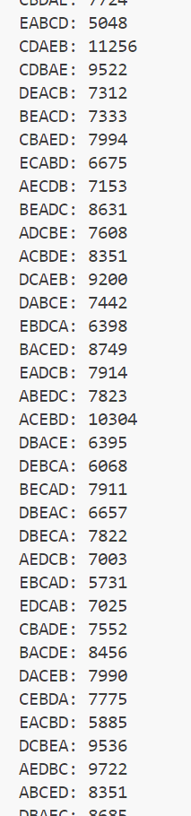
Ch 5 Programming- Permutations
CS3000
Rebekah Jensen

random_in_place
This function was based on one in the book, so it was easy to craft up, a for the array and n for the length of said array.

permute_w_all
Like above, this was another one from the book. And similarly to the first function, it was interesting to implement random.randint and swap. It was very similar to other programming assignments I’ve already completed for this class, so no worries there.

a_to_str
This method just turns my array into a string as per the instructions.

testing
After a few attempts at getting this just right, I think I finally did it with the help of a friend. Instead of putting so much code into my testing, I simplified this method to copy my array and return my string array to the original array with the copy.

main
Once again, I wouldn’t have been able to fix this if my friend hadn’t helped me. I put a lot more code into the main and simply called it at the bottom of my program. I find the results for randomizing in place and permutations and print them.

plotting
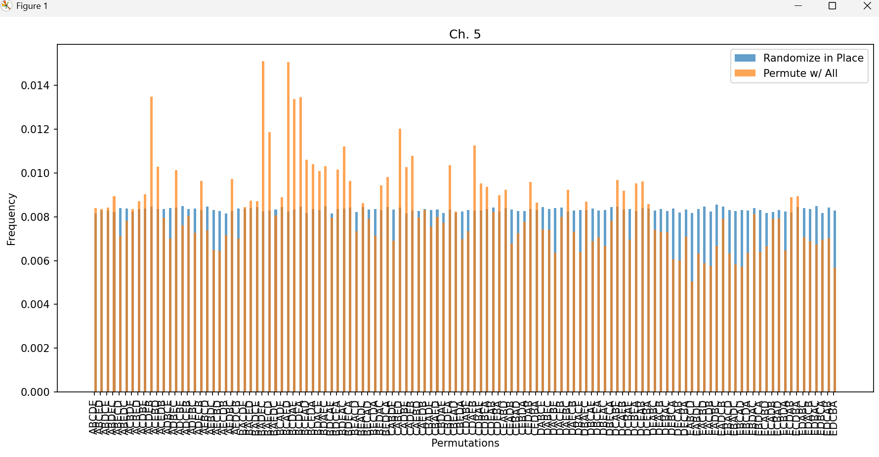
I figured out my sorted permutations after being randomized and the rate (frequencies) of the random results and the permutation results. I plotted the graph much better than before and was able to include both the randomize results and permutation results on one graph. Phew!

